Cardiac Interoceptive Accuracy, ADHD Traits, and Flexible Regulation of Emotional Expression in Adults

Aleksandra Malecka-Urban
University of Essex Online
Module name: Psychobiology and Neuroscience
Date: 14/09/2026
Word count 2139

Proposal Declaration
I Aleksandra Malecka-Urban
declare that this proposal has been composed solely by myself and that it has not been submitted, in whole or in part, in any previous application for a degree. Except where states otherwise, by reference or acknowledgement, the work presented is entirely my own and has been generated by me as the result of my own original research.
If generative AI has been used, I have cited the source, and I have not plagiarised AI generated content, but have used it for support with research planning, clarification of methodological and statistical concepts, and feedback on the structure and clarity of the proposal ensuring that all work is in my own words and based on my own understanding.
Signed: Aleksandra Malecka-Urban
Date: 14/09/2026

Cardiac Interoceptive Accuracy, ADHD Traits, and Flexible Regulation of Emotional Expression in Adults

Background Literature Review

Introception can be defined as the ability to sense, process, and represent physiological signals from within the body, including respiratory, cardiovascular, and gastrointestinal signals (Khalsa et al., 2018). Across different dimensions, the differences in introception may be conceptualised, which includes introceptive accuracy – reflecting objectively measured performance in detecting signals from the body, where introceptive sensibility refers more to self-reported perception and beliefs concerning internal states of a person (Garfinkel et al., 2015). Cardiac introceptive accuracy is usually assessed through performance-based heartbeat perception tasks. Next, neuroimaging evidence indicates that cardiac introceptive processing involves regions which are including the insular and anterior cingulate cortices, with right anterior insula activity associated with heartbeat detection accuracy (Critchley et al., 2004). Cardiac interoceptive accuracy may be relevant to emotion regulation, as interoceptive representations contribute to emotional experience and interpretation (Critchley & Garfinkel, 2017).

Rising evidence suggesting that cardiac interoceptive accuracy can contribute to emotion regulation, even though the relationship is not well established. Greater heartbeat perception accuracy may be associated with more effective down-regulation of negative affect during cognitive reappraisal (Füstös et al., 2013). For example, Schuette et al. (2021) found that self-reported dimensions of introception predicted emotion identification and regulation, whereas objectively measured heartbeat perception accuracy did not. Pinna and Edwards (2020) presented a systematic review and identified only three studies examining introception in relation to emotion regulation, underscoring the limited and inconsistent current evidence base.

Critchley & Garfinkel (2017) proposed one possible mechanism: accurate representation of physiological change may provide information about the emergence or alteration of emotional states, contributing to regulatory feedback about whether an emotional response is changing and whether regulatory responses should be adjusted. This does not imply that greater interoceptive accuracy is inherently adaptive; rather, cardiac information can constitute one source of feedback whose usefulness depends on its interpretation alongside contextual information. Significantly, existing research has largely examined particular regulatory strategies rather than whether interoceptive accuracy supports adaptation of emotional responses across changing situational demands.

Prior Findings
Traits of ADHD can provide a relevant individual-differences context in which to examine these processes, as ADHD and ADHD-related traits have been associated with both difficulties in emotion regulation and altered interoceptive processing. One of the most recent systematic reviews has found that poor interoceptive functioning was in general associated with more ADHD symptoms, including hyperactivity, inattention and impulsivity. Nevertheless, findings vary across measures and studies and were limited by methodological heterogeneity (Bruton et al., 2025). Evidence for emotion-regulation difficulties is more consistent: a meta-analysis of adults with ADHD reported greater overall emotion dysregulation than in non-ADHD controls, and a moderate-to-strong link between ADHD symptom severity and emotion dysregulation (Beheshti et al., 2020).
Nevertheless, the literaturę has mainly conceptualised emotional functioning in terms of dysregulation and strategy use, as systematic-review evidence indicates methodological heterogeneity and inconsistent findings across specific regulatory strategies (Soler- Gutiérrez et al., 2023). Furthermore, relationships between emotion regulation, interoception, and ADHD have been investigated, but separately. Therefore, it remains unclear whether ADHD traits can contribute to expressive flexibility when objectively measured cardiac introceptive accuracy is considered simultaneously. A dimensional approach also allows ADHD-related traits to be examined in a non-clinical sample, where questionnaire scores are not treated as evidence of diagnosis.

Theory
Regulatory Flexibility Theory offers a broader perspective, proposing that adaptive regulation depends on adjusting regulatory responses to changing situational demands, rather than relying on strategies assumed to be inherently adaptive or maladaptive (Bonnano & Burton, 2013). The framework identifies three interacting components: access to a repertoire of regulatory strategies, sensitivity to contextual demands, and responsiveness to feedback about their effectiveness. Bonanno and Burton (2013) have noted that sensitivity may provide a theoretical link between interoception and regulatory flexibility.
More accurate detection of changes in bodily state may be providing more accurate information about changes in internal state during an emotional response. It can also potentially support decisions about whether an expressive response should be modified. Expressive flexibility can be examined using the Flexible Regulation of Emotional Expression (FREE) Scale, which assesses the ability to enhance and suppress emotional expression across different situational contexts (Burton & Bonanno, 2016). Expressive flexibility refers to the capacity to modify emotional expression in accordance with contextual demands, rather than treating enhancement or suppression as uniformly adaptive.

Therefore, cardiac interoceptive accuracy can represent one component of the regulatory system, but cannot represent a sufficient basis for flexibility itself. However, examination of cardiac interoceptive accuracy alongside ADHD traits allows physiological and psychological individual differences that can contribute to expressive abilities to be considered simultaneously.

Rationale and Hypotheses
ADHD traits may contribute independently to expressive flexibility, given their associations with introceptive processing and emotion dysregulation (Beheshti et al., 2020; Bruton et al., 2025). Nevertheless, it remains unclear whether objective measures of cardiac introceptive accuracy and dimensional ADHD traits can account for variation in flexible suppression and enhancement of emotional expression independently. The presented study aims to address this gap by examining both as simultaneous predictors of enhancement and suppression abilities, which will be analysed separately, in a non-clinical sample.
The study aims to address the following research question:

To what extent do cardiac introceptive accuracy and ADHD traits predict flexible regulation of emotional expression in adults?

Taking into account evidence linking cardiac interoceptive accuracy with emotion regulation (Füstös et al., 2013) and the proposed role of bodily-state sensitivity in regulatory flexibility (Bonanno & Burton, 2013), the study hypothesised that:

H1: Greater cardiac interoceptive accuracy will predict higher perceived enhancement and suppression ability.

Given evidence linking ADHD symptoms with emotion-regulation difficulties (Beheshti et al., 2020), it is further hypothesised that:

H2: Higher ADHD traits will predict lower perceived enhancement and suppression ability.

The association between ADHD traits and cardiac interoceptive accuracy will be examined exploratorily because findings in the existing literature are inconsistent (Bruton et al., 2025).

Aims and Objectives
The primary aim of the proposed study is to investigate whether ADHD traits and cardiac introceptive accuracy will predict individual differences in the flexible regulation of emotional expression in an adult sample. The study will especially focus on: (1) examining whether cardiac introceptive accuracy predicts perceived enhancement and suppression ability; (2) examining whether ADHD traits on their own predict these outcomes when considered alongside cardiac interoceptive accuracy; and (3) studying the association between ADHD traits and cardiac introceptive accuracy.

Research Design

Design

This study will use a quantitative, cross-sectional correlational design to examine whether individual differences in cardiac introceptive accuracy and ADHD traits predict flexible regulation of emotional expression in an adult sample. ADHD traits and cardiac introceptive accuracy will constitute the predictor variables, while enhancement and suppression abilities will be separate outcome variables.

Materials

The study will use the Staircase-Heartbeat Discrimination Task (S-HDT; Savage et al., 2026; see Appendix F) to assess cardiac introceptive accuracy. S-HDT is a recent development of performance-based measure design that addresses recognised limitations of traditional heartbeat discrimination paradigms. To record cardiac activity, the study will use electrocardiography (ECG), which will provide R-wave timing against which participants’ heartbeat judgements can be referenced. The S-HDT adaptively varies the temporal delay between cardiac events and external stimuli according to participants’ responses, allowing estimation of cardiac interoceptive accuracy alongside the point of subjective simultaneity (PSS).

Secondly, the study will assess flexible regulation of emotional expression with use of the Flexible Regulation of Emotional Expression (FREE) Scale (Burton & Bonanno, 2016; see Appendix E), with perceived enhancement and suppression ability scored separately. Continuing, the ADHD traits will be measured continuously with use of the 18-item Adult ADHD Self-Report Scale v1.1 (ASRS-v1.1; Kessler et al., 2005; see Appendix D). Scores range from 0 (Never) to 4 (Very Often) and will be summed to produce a continuous total score from 0 to 72, where higher scores indicate greater ADHD-related symptom traits (Brevik et al., 2020).

Participants

Participants will be 140 adults aged 18 years or over recruited from a non-clinical population. An a priori power analysis for multiple linear regression with two predictors, assuming a medium effect size (f² = .15), α = .05, and 80% power, indicated approximately 68 analysable participants. Because Savage et al. (2026) retained 22 of 42 participants (52.38%) after S-HDT exclusions, recruiting 140 participants should provide approximately 73 usable datasets while allowing for questionnaire or ECG-related data loss.

Participants must have sufficient English proficiency to understand the task instructions and questionnaire items. Individuals reporting cardiovascular or neurological conditions that could substantially affect cardiac signalling or task performance will be excluded. ADHD diagnosis will not be required, as ADHD traits will be measured continuously using the ASRS-v1.1. Relevant medication use, particularly medication that may influence cardiovascular function, will be recorded and considered when interpreting cardiac measurements.

Data Analysis Plan

Before analysis, study will screen the data for missing values, outliers, incomplete questionnaires, and unusable S-HDT or ECG recordings. The S-HDT exclusion criteria will be applied before statistical analysis. Next, descriptive statistics will be calculated for all study variables.

To evaluate the research hypotheses, two multiple linear regression analyses will be conducted. The first will test H1 and H2 using cardiac interoceptive accuracy and ADHD traits as simultaneous predictors of enhancement ability. The second will use the same predictors to examine suppression ability. This approach is appropriate because the study examines whether two continuous predictor variables independently predict continuous outcome variables.

Prior to conducting the regressions, assumptions of linearity, homoscedasticity, normally distributed residuals, multicollinearity, and influential observations will be assessed. Statistical significance will be set at p < .05, and model fit, regression coefficients, and 95% confidence intervals will be reported.

Finally, the association between ADHD traits and cardiac interoceptive accuracy will be examined exploratorily using Pearson’s correlation coefficient. If its assumptions are substantially violated, Spearman’s rank correlation will be used instead.

Procedure

After gathering consent from the participants, they will next complete demographic information and the questionnaires (ASRS-v1.1 and FREE). Next, the ECG electrodes will be attached, and participants will complete the S-HDT in a calm, quiet laboratory environment. While participants are completing the task, the cardiac activity will be continuously recorded, with ECG R-waves providing the temporal reference for heartbeat stimuli. The delay between cardiac events and external stimuli will be adaptively adjusted according to participants’ responses, following the S-HDT procedure described by Savage et al. (2026). The task will take approximately 30 minutes. After completing the task, ECG equipment will be removed, and participants will receive a written debrief explaining the purpose of the study and reminding them that ASRS-v1.1 scores are not equivalent to a clinical diagnosis.

Ethics

Ethical approval will be obtained from the University of Essex Online, Department of Psychology and Criminology, prior to data collection. All participants will receive a Participant Information Sheet and will provide informed consent before participation.

The data from the research will be pseudonymised using participant codes with identifying information stored separately. It will be possible for participants to request withdrawal of their data while the data stay linked to the participant code; once the dataset has been fully anonymised, individual data will no longer be identifiable or removable. Data will be stored securely in accordance with University and British Psychological Society ethical guidance (Oates et al., 2021).

The study will use non-invasive recording, such as ECG. Nevertheless, participants will receive information about the procedure beforehand and can discontinue participation if they experience any discomfort. Regarding the ASRS-v1.1, participants will be explicitly informed that, although the scale measures ADHD symptoms, it does not provide a diagnosis; it is a screening measure. That information aims to reduce the risk of inappropriate self-diagnosis or self-labelling. A debrief will be provided and will inform about appropriate sources of support in case of concern or distress.

Limitations

There are many limitations that should be considered in this study. First, the cross-sectional design precludes causal conclusions regarding the relationship between cardiac inroceptive accuracy and expressive flexibility. Second, the FREE scale relies on self-reported responses to hypothetical scenarios and cannot fully reflect regulatory behaviour in everyday situations, even though it provides a validated measure of perceived enhancement and suppression ability (Burton & Bonanno, 2016). Third, S-HTD is a relatively new measure with limited independent validation; it still needs further investigation,, especially regarding its psychometric properties (Savage et al.). The S-HDT analysis pipeline also excludes participants whose response patterns are classified as random or consistent with a non-interoceptive cognitive strategy, which can potentially result in data loss. If the likelihood of exclusion is systematically associated with ADHD traits, this could additionally bias estimates of the relationships examined. Moving forward, performance on a cardiac introception task represents one specific dimension and modality of introceptive functioning and should not be considered as a comprehensive measure of participants' broader introceptive abilities. Overall, the study can address issues with increased sensitivity but has limitations in generalisation to individual differences in a non-clinical sample when assessing ADHD dimensionally.

Timeline
Work package | Main activities | Indicative timing
1. Finalise research protocol | Finalise measures, S-HDT/ECG procedure, participant materials, and analysis plan. | Weeks 1–2
2. Ethics review | Submit the ethics application and address any requested revisions. | Weeks 3–5
3. Recruitment and data collection | Recruit eligible participants and complete questionnaire, ECG and S-HDT data collection after ethical approval. | Weeks 6–12
4. Data preparation | Prepare ECG/S-HDT data, apply predefined exclusion criteria, and screen the dataset. | Weeks 13–14
5. Data analysis | Conduct the two multiple regression analyses and exploratory correlation and summarise the findings. | Weeks 15–16
6. Write-up | Complete the results, discussion, and remaining project sections. | Weeks 17–18
7. Revision and submission | Proofread, check APA formatting and references, and prepare the final submission. | Week 19

References
Beheshti, A., Chavanon, M.-L., & Christiansen, H. (2020). Emotion dysregulation in adults with attention deficit hyperactivity disorder: A meta-analysis. BMC Psychiatry, 20(1), 120. https://doi.org/10.1186/s12888-020-2442-7
Bonanno, G. A., & Burton, C. L. (2013). Regulatory flexibility: An individual differences perspective on coping and emotion regulation. Perspectives on Psychological Science, 8(6), 591–612. https://doi.org/10.1177/1745691613504116
Brevik, E. J., Lundervold, A. J., Haavik, J., & Posserud, M.-B. (2020). Validity and accuracy of the Adult Attention-Deficit/Hyperactivity Disorder (ADHD) Self-Report Scale (ASRS) and the Wender Utah Rating Scale (WURS) symptom checklists in discriminating between adults with and without ADHD. Brain and Behavior, 10(6), e01605. https://doi.org/10.1002/brb3.1605
Bruton, A. M., Levy, L., Rai, N. K., Colgan, D. D., & Johnstone, J. M. (2025). Diminished interoceptive accuracy in attention-deficit/hyperactivity disorder: A systematic review. Psychophysiology, 62(2), e14750. https://doi.org/10.1111/psyp.14750
Burton, C. L., & Bonanno, G. A. (2016). Measuring ability to enhance and suppress emotional expression: The Flexible Regulation of Emotional Expression (FREE) Scale. Psychological Assessment, 28(8), 929–941. https://doi.org/10.1037/pas0000231
Critchley, H. D., & Garfinkel, S. N. (2017). Interoception and emotion. Current Opinion in Psychology, 17, 7–14. https://doi.org/10.1016/j.copsyc.2017.04.020
Critchley, H. D., Wiens, S., Rotshtein, P., Öhman, A., & Dolan, R. J. (2004). Neural systems supporting interoceptive awareness. Nature Neuroscience, 7(2), 189–195. https://doi.org/10.1038/nn1176
Füstös, J., Gramann, K., Herbert, B. M., & Pollatos, O. (2013). On the embodiment of emotion regulation: Interoceptive awareness facilitates reappraisal. Social Cognitive and Affective Neuroscience, 8(8), 911–917. https://doi.org/10.1093/scan/nss089
Garfinkel, S. N., Seth, A. K., Barrett, A. B., Suzuki, K., & Critchley, H. D. (2015). Knowing your own heart: Distinguishing interoceptive accuracy from interoceptive awareness. Biological Psychology, 104, 65–74. https://doi.org/10.1016/j.biopsycho.2014.11.004
Kessler, R. C., Adler, L., Ames, M., Demler, O., Faraone, S., Hiripi, E., Howes, M. J., Jin, R., Secnik, K., Spencer, T., Ustun, T. B., & Walters, E. E. (2005). The World Health Organization Adult ADHD Self-Report Scale (ASRS): A short screening scale for use in the general population. Psychological Medicine, 35(2), 245–256. https://doi.org/10.1017/S0033291704002892
Khalsa, S. S., Adolphs, R., Cameron, O. G., Critchley, H. D., Davenport, P. W., Feinstein, J. S., Feusner, J. D., Garfinkel, S. N., Lane, R. D., Mehling, W. E., Meuret, A. E., Nemeroff, C. B., Oppenheimer, S., Petzschner, F. H., Pollatos, O., Rhudy, J. L., Schramm, L. P., Simmons, W. K., Stein, M. B., … Paulus, M. P. (2018). Interoception and mental health: A roadmap. Biological Psychiatry: Cognitive Neuroscience and Neuroimaging, 3(6), 501–513. https://doi.org/10.1016/j.bpsc.2017.12.004
Oates, J., Carpenter, D., Fisher, M., Goodson, S., Hannah, B., Kwiatkowski, R., Prutton, K., Reeves, D., & Wainwright, T. (2021). BPS code of human research ethics. British Psychological Society. https://doi.org/10.53841/bpsrep.2021.inf180
Pinna, T., & Edwards, D. J. (2020). A systematic review of associations between interoception, vagal tone, and emotional regulation: Potential applications for mental health, wellbeing, psychological flexibility, and chronic conditions. Frontiers in Psychology, 11, 1792. https://doi.org/10.3389/fpsyg.2020.01792
Savage, H. S., Longley, B. F., Lim, W. P. H., Nord, C. L., Kilner, J., & Garfinkel, S. N. (2026). The staircase-heartbeat discrimination task (S-HDT). Biological Psychology, 204, 109206. https://doi.org/10.1016/j.biopsycho.2026.109206
Schuette, S. A., Zucker, N. L., & Smoski, M. J. (2021). Do interoceptive accuracy and interoceptive sensibility predict emotion regulation? Psychological Research, 85(5), 1894–1908. https://doi.org/10.1007/s00426-020-01369-2
Soler-Gutiérrez, A.-M., Pérez-González, J.-C., & Mayas, J. (2023). Evidence of emotion dysregulation as a core symptom of adult ADHD: A systematic review. PLOS ONE, 18(1), e0280131. https://doi.org/10.1371/journal.pone.0280131

Appendix A

Participant Information Sheet

Participant Information Sheet

Study title: Cardiac Interoceptive Accuracy, ADHD Traits, and Flexible Regulation of Emotional Expression in Adults

Researcher: Aleksandra Malecka-Urban
University: University of Essex Online, Department of Psychology and Criminology

What is the purpose of the study?

This study aims to investigate whether cardiac interoceptive accuracy and ADHD traits predict individual differences in the flexible regulation of emotional expression in adults. Cardiac interoceptive accuracy refers to an individual's ability to accurately perceive signals associated with their heartbeat.

Why have I been invited?

You are invited to participate because you are aged 18 years or over and have sufficient English proficiency to understand the study instructions and questionnaires. You do not need to have a diagnosis of ADHD to participate.

Individuals reporting cardiovascular or neurological conditions that could substantially affect cardiac signalling or performance on the heartbeat task will not be eligible to participate.

What will happen if I take part?

If you agree to participate, you will first complete demographic questions and two questionnaires assessing ADHD-related traits and the flexible regulation of emotional expression.

Your cardiac activity will then be recorded using electrocardiography (ECG). ECG electrodes will be attached to your body to record the electrical activity associated with your heartbeat. You will complete the Staircase-Heartbeat Discrimination Task (S-HDT), during which you will make judgements about the timing of your heartbeat in relation to external stimuli.

The S-HDT is expected to take approximately 30 minutes.

Are there any risks or disadvantages?

ECG is a non-invasive recording procedure. However, you may experience minor discomfort associated with the placement or removal of ECG electrodes.

Some questions concern ADHD-related symptoms and emotional functioning. These questions may cause mild discomfort or concern for some participants. You may discontinue participation if you feel uncomfortable.

The Adult ADHD Self-Report Scale (ASRS-v1.1) used in this research is a screening measure and does not provide a clinical diagnosis of ADHD.

Do I have to participate?

No. Participation is entirely voluntary. You may stop participating during the research session without having to provide a reason.

You may also request withdrawal of your research data while those data can still be linked to your participant code. Once the research dataset has been fully anonymised, it will no longer be possible to identify and remove an individual participant's data.

What will happen to my data?

Research data will initially be pseudonymised using a participant code. Information capable of identifying you will be stored separately from the research data.

The University of Essex is the Data Controller. Personal data used for research will be processed under UK GDPR Article 6(1)(e), public task. Where special-category personal data are processed for scientific research, Article 9(2)(j) will apply.

Research data will be stored securely in accordance with University of Essex requirements and retained for a minimum of three years following completion of the project. Fully anonymised information may be used in the reporting of the research.

What happens after participation?

Following completion of the study, you will receive a written debrief explaining the purpose of the research and reminding you that the ASRS-v1.1 is not a diagnostic assessment.

Who can I contact?

Researcher: Aleksandra Malecka-Urban
Email: aleksandra.malecka.uk@gmail.com

Supervisor/module contact: Dr Mark Ashton-Smith

Email: mark.ashton-smith@kaplan.com

For concerns about data protection:
University of Essex Data Protection Officer
dataprotectionofficer@essex.ac.uk

Appendix B

Consent Form
Study title: Cardiac Interoceptive Accuracy, ADHD Traits, and Flexible Regulation of Emotional Expression in Adults

Please indicate your agreement with each statement:
- I confirm that I have read and understood the Participant Information Sheet for this study and have had the opportunity to consider the information provided.
- I understand the purpose and procedures of the study.
- I understand that my participation is voluntary and that I may stop participating without providing a reason.
- I understand the arrangements concerning withdrawal of my data and that withdrawal will no longer be possible once my data have been fully anonymised.
- I understand that I will complete questionnaires concerning ADHD-related traits and emotional functioning.
- I understand that the ASRS-v1.1 is a screening measure and does not provide a clinical diagnosis of ADHD.
- I understand that my cardiac activity will be recorded using electrocardiography (ECG).
- I understand that ECG is non-invasive but that I may experience minor discomfort associated with the placement or removal of electrodes.
- I confirm that I am aged 18 years or over.
- I confirm that I have sufficient English proficiency to understand the study instructions and questionnaires.
- I confirm that I do not have a cardiovascular or neurological condition that I am aware of which would substantially affect cardiac signalling or my ability to complete the task.
- I understand how my information will be stored and used and consent to participate in this research.
Participant name: ______________________________
Signature: ____________________________________
Date: ________________________________________
Participant code: ______________________________

Appendix C.

Debrief Form
Study title: Cardiac Interoceptive Accuracy, ADHD Traits, and Flexible Regulation of Emotional Expression in Adults

Thank you for participating in this study.
The purpose of this research is to investigate whether individual differences in cardiac interoceptive accuracy and ADHD traits predict flexible regulation of emotional expression.
Cardiac interoceptive accuracy was assessed using the Staircase-Heartbeat Discrimination Task (S-HDT) while cardiac activity was recorded using ECG. Flexible regulation of emotional expression was assessed using the FREE Scale, while ADHD-related traits were measured using the ASRS-v1.1.
The study examines whether greater cardiac interoceptive accuracy predicts greater perceived ability to enhance and suppress emotional expression and whether higher ADHD traits predict lower perceived enhancement and suppression ability. The relationship between ADHD traits and cardiac interoceptive accuracy will also be examined exploratorily.
Important information about the ASRS-v1.1
The ASRS-v1.1 used in this research is a screening questionnaire. Your responses or score do not constitute a diagnosis of ADHD and should not be interpreted as evidence that you have or do not have ADHD.
If completing the study has raised concerns about ADHD symptoms, emotional functioning, or your wellbeing, you may wish to discuss these concerns with an appropriate healthcare professional, such as your GP. NHS information and support are also available through NHS services.

Withdrawal of data
You may request withdrawal of your data while your responses remain linked to your participant code. Once the dataset has been fully anonymised, it will no longer be possible to identify and remove individual data.
Contact details
Researcher: Aleksandra Malecka-Urban
Email: aleksandra.malecka.uk@gmail.com
Supervisor/module contact: Dr Mark Ashton-Smith mark.ashton-smith@kaplan.com

Thank you for contributing to this research.

Appendix D.

Adult ADHD Self-Report Scale v1.1 (ASRS-v1.1)
ADHD traits will be assessed using the 18-item Adult ADHD Self-Report Scale v1.1 (ASRS-v1.1) Symptom Checklist (Kessler et al., 2005).
For the purposes of this study, all 18 items will be used dimensionally. Responses will be coded:
Never = 0
Rarely = 1
Sometimes = 2
Often = 3
Very Often = 4
Scores across the 18 items will be summed to produce a continuous total score ranging from 0 to 72, with higher scores representing greater ADHD-related symptom traits (Brevik et al., 2020).
The ASRS-v1.1 will not be used to establish an ADHD diagnosis or to categorise participants into diagnostic groups.
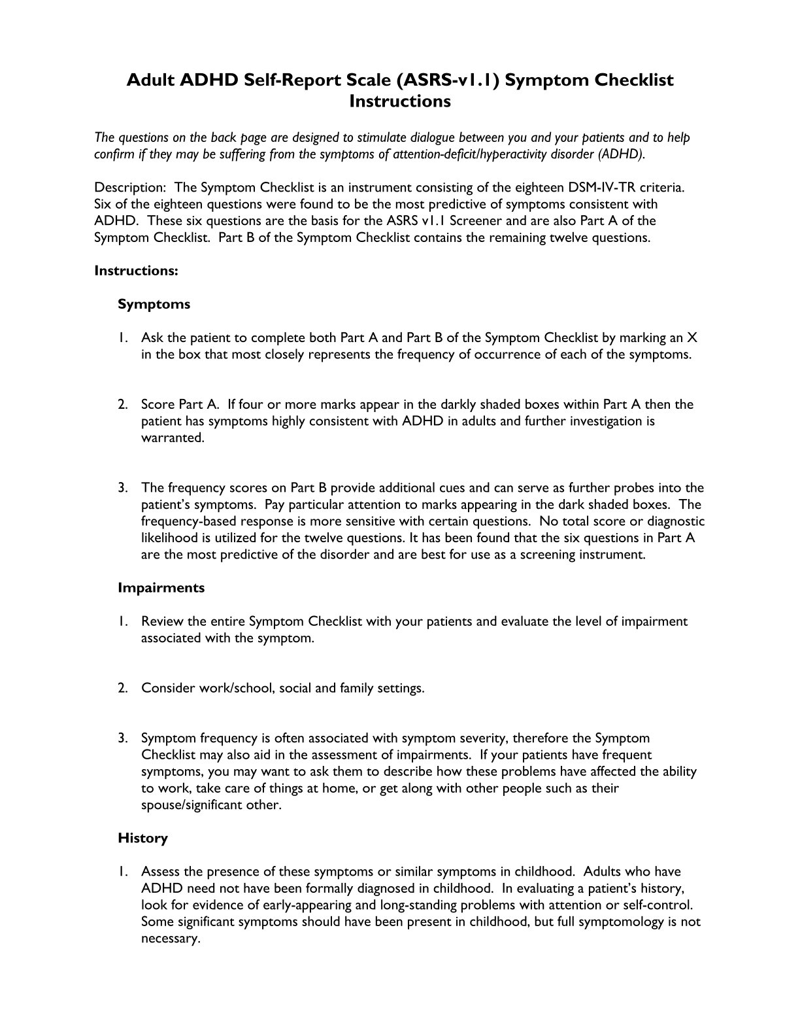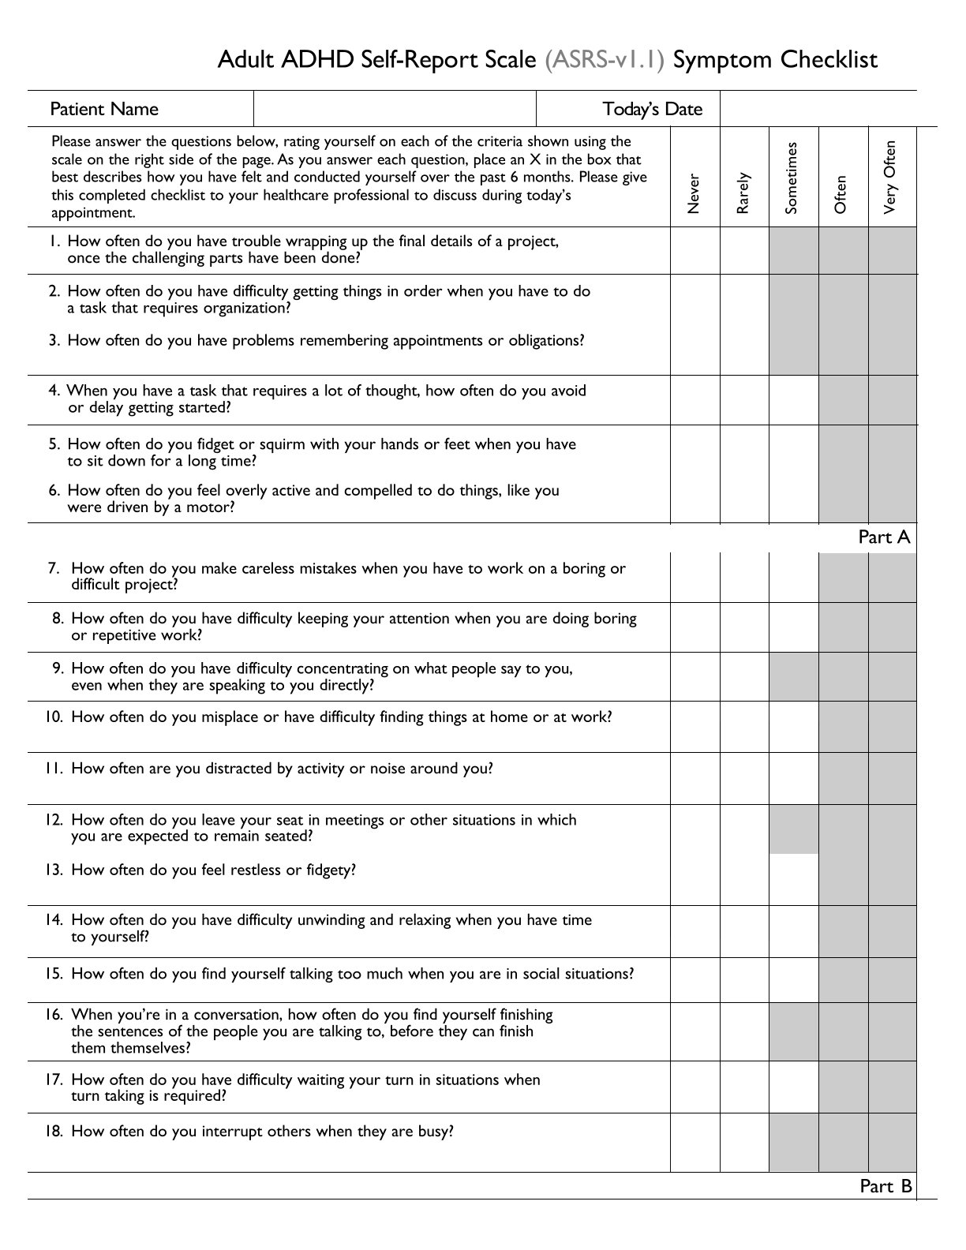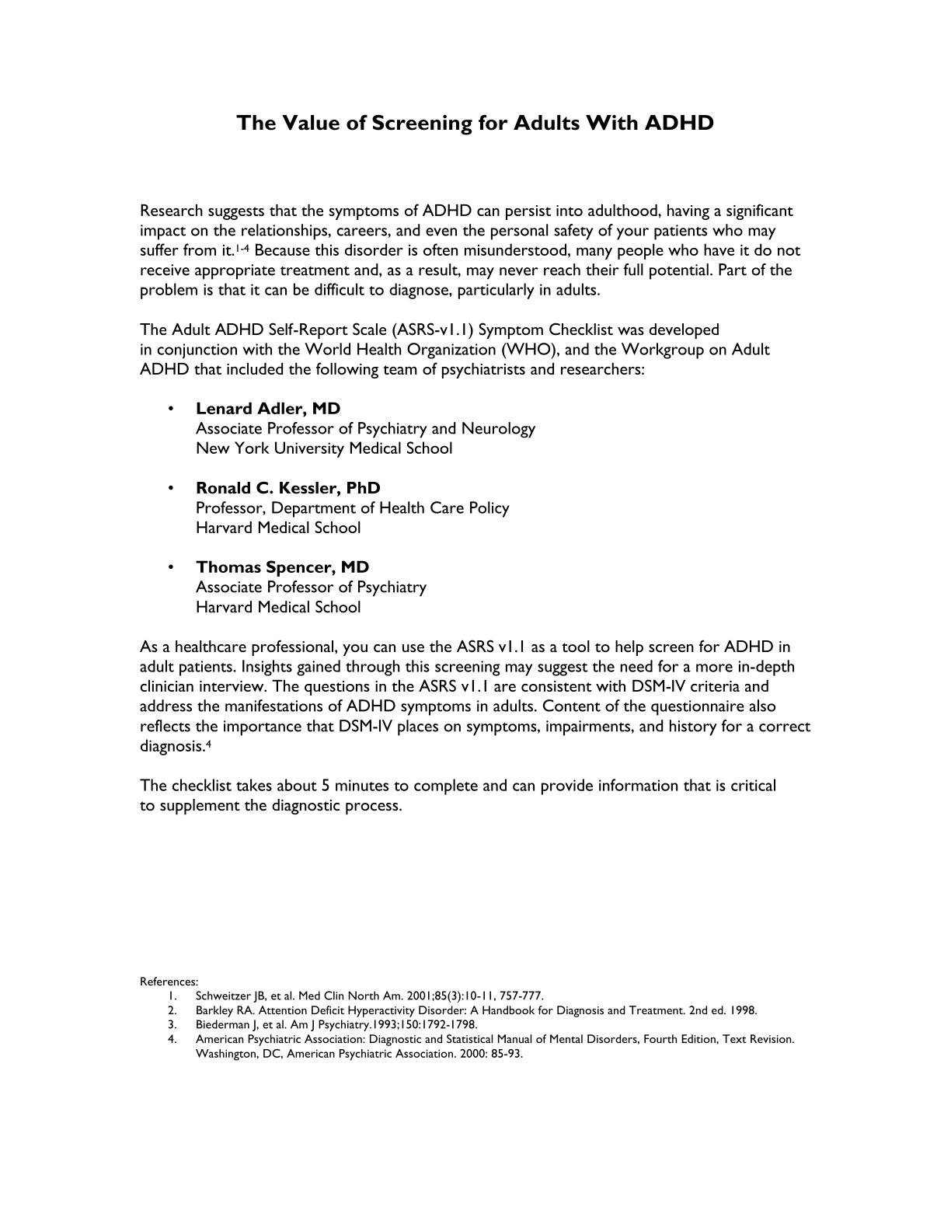

Appendix E
Flexible Regulation of Emotional Expression (FREE) Scale

Flexible regulation of emotional expression will be assessed using the Flexible Regulation of Emotional Expression (FREE) Scale (Burton & Bonanno, 2016).
The scale contains 16 scenarios assessing perceived ability to modify emotional expression across different situations. Responses range from:
1 = Unable to 6 = Very able
For the present study, the scale will be scored as two separate outcomes:
Enhancement ability: sum of items 1–8
Suppression ability: sum of items 9–16
Enhancement and suppression scores will be analysed separately in accordance with the study hypotheses. An overall expressive-flexibility score will therefore not be used as the primary outcome.
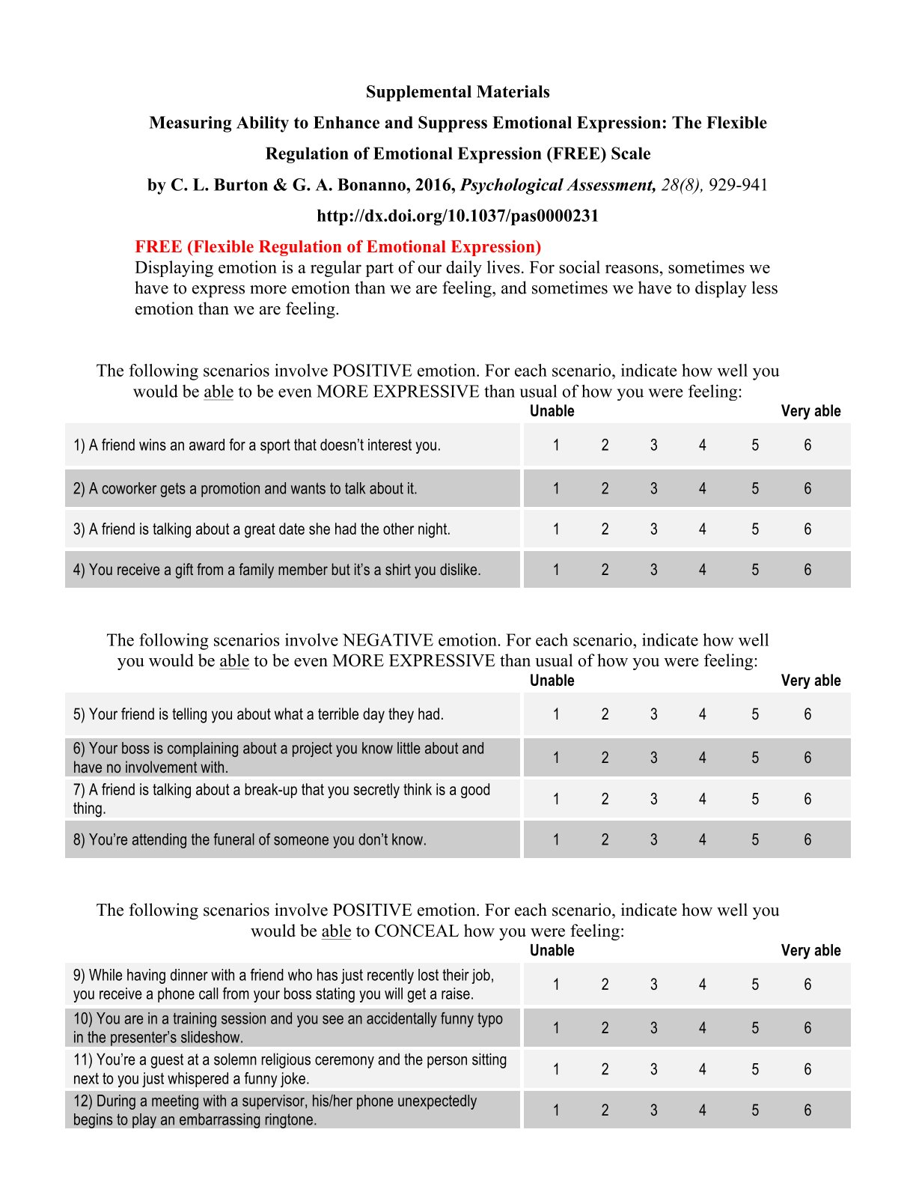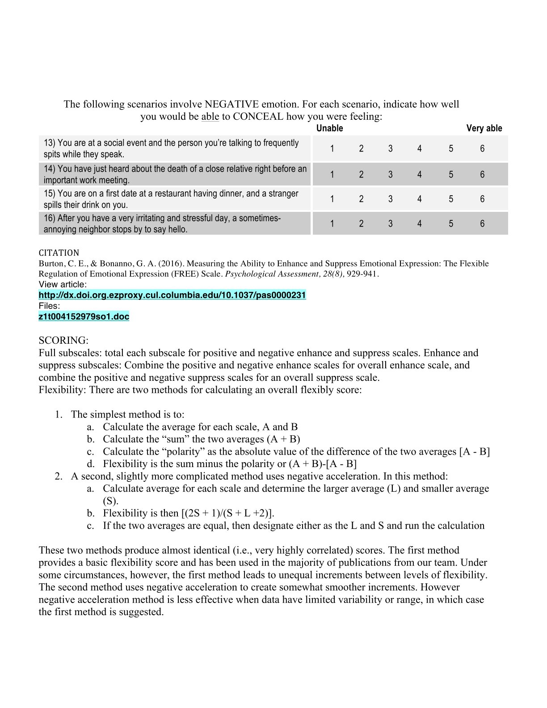

Appendix F

Staircase-Heartbeat Discrimination Task (S-HDT) Protocol and Materials

Cardiac interoceptive accuracy will be assessed using the Staircase-Heartbeat Discrimination Task (S-HDT) developed by Savage et al. (2026).
Cardiac activity will be continuously recorded using electrocardiography (ECG). ECG R-waves will provide the temporal reference for presentation of heartbeat-related auditory stimuli.

The S-HDT uses an adaptive procedure in which participants judge the temporal relationship between their heartbeat and externally presented tones. During training, participants complete between 2 and 20 training trials, with each trial consisting of 10 tones presented in relation to every second heartbeat. Stimulus delays range from 0 to 600 ms in 50-ms increments.
The adaptive staircase procedure consists of four blocks of 15 trials, initiated at different delays:
400A → 100A → 400B → 100B
The temporal delay is adjusted according to participants' responses concerning whether the tones occurred before, after, or at approximately the same time as their perceived heartbeat. Confidence judgements are also collected as part of the task but will not constitute a primary variable in the proposed analyses.
The task permits estimation of cardiac interoceptive performance and the point of subjective simultaneity (PSS). Cardiac interoceptive accuracy derived from the S-HDT will constitute the primary physiological predictor in the proposed regression analyses.
Predefined S-HDT data-quality criteria will be applied before statistical analysis, following the published procedure described by Savage et al. (2026). Response patterns classified as consistent with random responding or a non-interoceptive cognitive strategy will be excluded from the primary analyses. The published simulated reference trajectories will be used as specified in the S-HDT analysis pipeline.
The S-HDT is a recently developed performance-based measure designed to address recognised limitations of traditional heartbeat discrimination paradigms. Its relatively recent development and limited independent validation are acknowledged in the proposal's limitations.
Reference:
Savage, H. S., Longley, B. F., Lim, W. P. H., Nord, C. L., Kilner, J., & Garfinkel, S. N. (2026). The staircase-heartbeat discrimination task (S-HDT). Biological Psychology, 204, 109206.

